1、

[https://item.taobao.com/item.htm?id=546722588126&ali_refid=a3_430582_1006:1103926377:N:%E7%83%AD%E6%88%90%E5%83%8F%E4%BB%AA:cc460431029ba078fe02d05cfe491618&ali_trackid=1_cc460431029ba078fe02d05cfe491618&spm=a230r.1.14.11#detail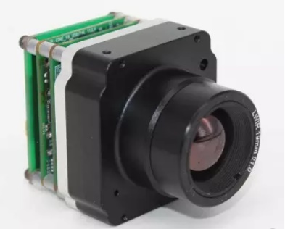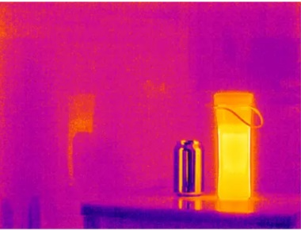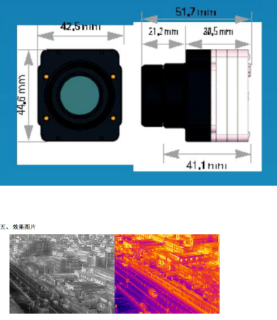](https://item.taobao.com/item.htm?id=546722588126&ali_refid=a3_430582_1006:1103926377:N:%E7%83%AD%E6%88%90%E5%83%8F%E4%BB%AA:cc460431029ba078fe02d05cfe491618&ali_trackid=1_cc460431029ba078fe02d05cfe491618&spm=a230r.1.14.11#detail###)

focus length  [visual angle](http://www.baidu.com/link?url=juH8EP5gEiFL4hNFQfksyB4fY23G32xwzHRUHE9crXejJbmv74Hgzvkq-WwWoYasSOjFVe3me6ce_fIZ_2kZQabFoMH6Lg5-SuzJ0G75RFjkPNCH8HKh3ZdYGb5Y3LcD)（ horizontal*vertical -diagonal）

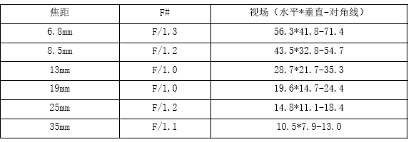

weight: 110g(without lens) 280g（with lens）

range : -20℃~550℃

accuracy：2℃

output ： USB CVBS

resolution ratio：640*480

linux & windows